**TRAINING NEURAL NETWORKS FOR ASPECT EXTRACTION**

1 INTRODUCTION

Here, we investigate whether neural networks can be effectively trained under this challenging setting using only weak supervision in the form of a small set of seed words, i.e., descriptive keywords

for each aspect.

2 BACKGROUND: NEURAL NETWORKS FOR ASPECT EXTRACTION

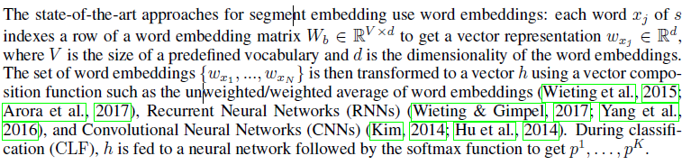

3 A DISTILLATION APPROACH FOR ASPECT EXTRACTION

In this work, we propose a weakly supervised approach for segment-level aspect extraction that leverages seed words as a stronger signal for supervision than MATE.

Teacher: A bag-of-words classifier using seed words

Student: An embedding-based neural network

4 EXPERIMENTS: ASPECT EXTRACTION IN PRODUCT REVIEWS